1. Recent Ads me kewal 14 ads dikhne chahiye o bhi latest updated ads.
2. Contact Us Tab me inquiry ka form lgana hai.

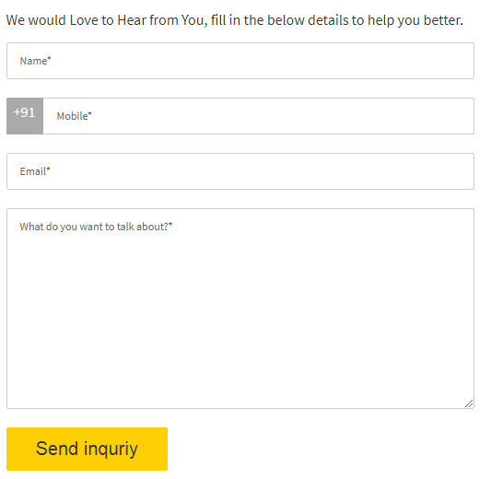

1. Profile Login user acount - Worng birthday

Worng gender

Edit Profile

1. Mail nhi aa rha hai account create krne pe.
2. In Login Forget Password Not working
3. keep me logged-in me password save hona chahiye n to ho nhi rha hai.
4. Search Box not working (add city and inter product name for the serching)
5. Popular Ads me current ka ads show chahiye. And 10 ads show hona chahiye kewal
6. Banner me link lga hona chahiye ki click krne pe uske sites pe chle jaye jis company ka banner ho.
7. News & Events Not Working
8. Recent Reviews not working
9. Consulting & Coaching me jo sites ka logo ho usme link lga hona chahiye jiska logo uska link new tab me open ho.
10. Footer me Business wale tab me advertisement with us ke niche Advertisments ka tab hona chahiye jo click hone pe sites ke sbhi ads dikhna chahiye.
11. Browse category

Search business

Login to your account ka link kaam nhi kr rha hai

1. Remove one Quick links tab

Browse category

Search business

Login to your account

1. Payments Option ka image add krna hai footer me and link lgana hai uspe jo ki next tab me account ka information open ho.
2. Link add krna hai social media ka footer me.