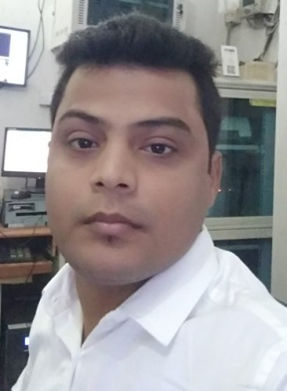



linkedin.com/in/atul-singh-13217758



atulsingh251@gmail.com

**ATUL SINGH**

Sales and Logistics Professional



+91.8009681400,

**ABOUT ME**

**WORK EXPERIENCE**  
6 Years

**I am a self driven with experiences. Able to work in critical circumstances.**



**Education**

**AGE**  
28

**Bachelor of Technology (IT)** Graduated, July 2012Lord krishna College of Engineering Ghaziabad Marks 61%  
Gautam Budh Technical University Division 1  
Lucknow, Uttar Pradesh

**10+2**  July 2006Govt Jubilee Inter College Gorakhpur Marks 55%  
Uttar Pradesh Board Division 2



**Career Highlights**

To seek a challenging position in a company where my knowledge and technical expertise will be utilized for growth of the organization as well my career.



**Skills**

* **Purchase Management**
* **Demand Management**
* **Logistics Management**
* **Customer Relationships**



**Work Experience**

* **Vendor Management**
* **Supply Chain Management**
* **Retail Outlet Product Sales**
* **Area Sales Management**

* **Business Development Management**
* **B2B Sale**
* **B2C Sale**

June 2017 – Current  
**Osts Manager**  
Bharat Petroleum Corporation Ltd  
Varanasi, Uttar Pradesh.

* Led a Phenomenal team to make my Retail Outlet Selling in the COCO/OSTS format
* Running  Premium Retailing Outlets
* Customer Engagement Program Development . Keeping Customer for ever Mechanism. Converting
* Customer Grievance into Business Enhancing Opportunity.
* Retail Outlet Management Training – need analysis & development
* Skill Improvement Training – design & workshops
* Motivation Workshops
* Self & Business Enrichment Workshops
* Customer Engagement Skills Training
* Training & developing the Executives Staff
* Handling Coco Related Problem by Vendor
* Handling Broma Complain
* Daily check Sap Reports & Stock Registers , Price Change
* Daily check Automations Reports

December 2012 – March 2017  
**Team Leader**  
Amcon Engineers Pvt Ltd  
Lucknow, Uttar Pradesh

* Cordinations with team members.
* Motivations with team members with quality works.
* Audit of site AT.



**Computer Proficiency**

* Computer operating system: Fluent in Windows 98/2000/2003/Vista/7 and knowledge of internet
* Word 2010
* Excel 2010
* Power Point 2010



**Languages**

* Hindi
* English



**Personal Interests**

|  |  |
| --- | --- |
| * Listening music | * cooking |
| * Singing   **Personal Details** |  |
|  |  |

Father’s Name: Indra Pratap Singh Marital Status: Single  
Birthday: January 25, 1991 Nationality: Indian  
Gender: Male

**Declaration**

I, Atul Singh, hereby declare that the information contained herein is true and correct to the best of my knowledge and belief.

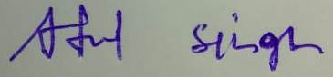 

____________________________  
Atul singh Varanasi, Uttar Pradesh